Solution

Part 1

Theory:
w
m
N
mg
Consider a small mass m of the liquid at the surface (Figure 1). At dynamic equilibrium
N cosθ = mg
and
N sinθ = mw²x
Therefore:
tanθ = 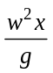.
Figure 1.
The profile of the liquid surface can be found as follows:
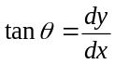, 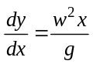
so that
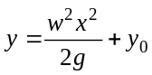
where y₀ is the height at x = 0.

At a certain point 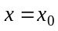, height of the liquid h₀ would be the same as if it not rotating. In this case,
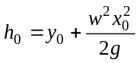 (1)
and,
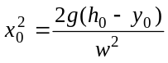.
Since the volume of the liquid is constant,
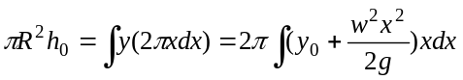,
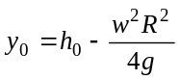 (2)

From Eq.1 and Eq.2 one obtains
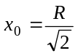.

Experiment:

2R(mm) | x₀(mm) | h₀(mm) | H(mm)
145 | 51 | 30 | 160

H-h₀=130 mm

Measure 10T at small speeds and measure 15T-20T at high speeds.
Use 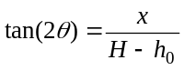 and 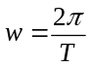.

2R(mm) | x₀(mm) |  | h₀(mm) | H(mm) | H-h₀(mm)
145 | 51 |  | 30 | 160 | 130

x(mm) | 10T(s) | w(rad/s) | tan(2θ) | θ(rad) | θ(deg) | tan(θ) | w²(rad/s)²
11 | 21.34 | 2.94 | 0.08 | 0.04 | 2.4 | 0.04 | 8.67
20 | 15.80 | 3.98 | 0.15 | 0.08 | 4.4 | 0.08 | 15.81
26 | 14.22 | 4.42 | 0.20 | 0.10 | 5.7 | 0.10 | 19.52
30 | 12.99 | 4.84 | 0.23 | 0.11 | 6.5 | 0.11 | 23.40
40 | 11.74 | 5.35 | 0.31 | 0.15 | 8.6 | 0.15 | 28.64
51 | 10.45 | 6.01 | 0.39 | 0.19 | 10.7 | 0.19 | 36.15
56 | 9.90 | 6.35 | 0.43 | 0.20 | 11.7 | 0.21 | 40.28
65 | 9.40 | 6.68 | 0.50 | 0.23 | 13.3 | 0.24 | 44.68
70 | 9.08 | 6.92 | 0.54 | 0.25 | 14.2 | 0.25 | 47.88
85 | 8.39 | 7.49 | 0.65 | 0.29 | 16.6 | 0.30 | 56.08
100 | 7.71 | 8.15 | 0.77 | 0.33 | 18.8 | 0.34 | 66.41
112 | 7.43 | 8.46 | 0.86 | 0.36 | 20.4 | 0.37 | 71.51
132 | 7.00 | 8.98 | 1.02 | 0.40 | 22.7 | 0.42 | 80.57
61.4 | 11.19 | 6.20 | 0.47 | 0.21 | 11.98 | 0.21 | 41.51 | Ave.

The last line is for error calculation only.

The slope of the Figure 2 is 0.0052 (s/rad)² which gives
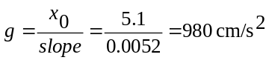.

Error Calculation (possible methods):
Figure 2.
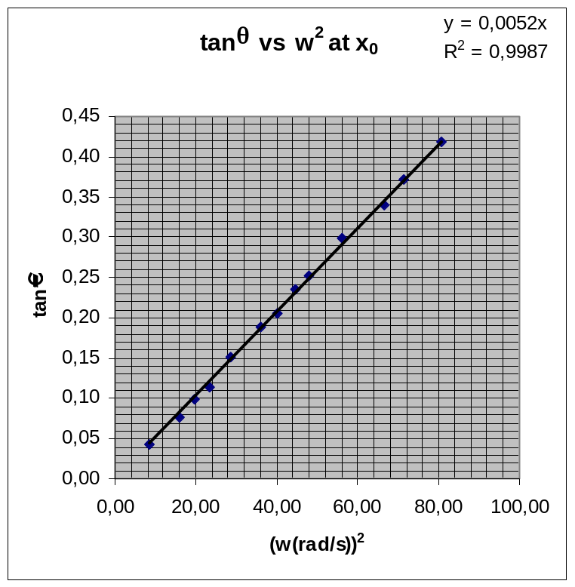
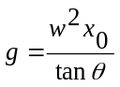
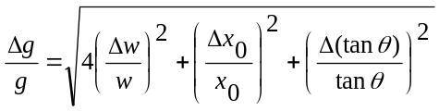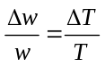
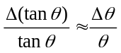
(since from the table tanθ ≅θ)
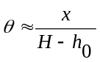,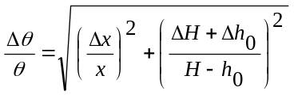
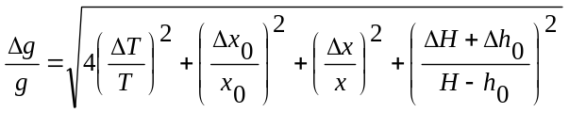

Using the values H=160 mm, ΔH=1mm, h₀=30 mm, Δh₀=1mm,x_{av}=61.4 mm, Δx_{av}=1mm, T_{av}=1.1s, ΔT=0.01 s, x₀=51 mm, Δx₀=1mm one obtains

g = 980±34 cm/s²

- Note that from the method of least squares one obtains the following results:

g = 982 cm/s² with a standard deviation of σ= 33 cm/s²

- From the linear regression of the data slope tanθ vs w² is found to be 0.052 with a standard error of 5.14x10⁻⁵, therefore:

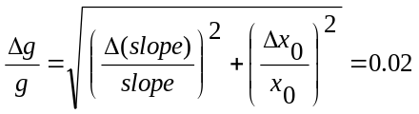

g = 980±20 cm/s²

Part 2a

H(mm) | 10T(s) | w(rad/s) | lnw | H-h₀(mm) | ln(H-h₀)
158 | 10.31 | 6.09 | 0.784921 | 128 | 2.107
209 | 13.19 | 4.76 | 0.677935 | 179 | 2.253
190 | 11.70 | 5.37 | 0.729994 | 160 | 2.204
150 | 9.80 | 6.41 | 0.806954 | 120 | 2.079
129 | 9.21 | 6.82 | 0.83392 | 99 | 1.996
119 | 8.75 | 7.18 | 0.856172 | 89 | 1.949
110 | 8.10 | 7.76 | 0.889695 | 80 | 1.903
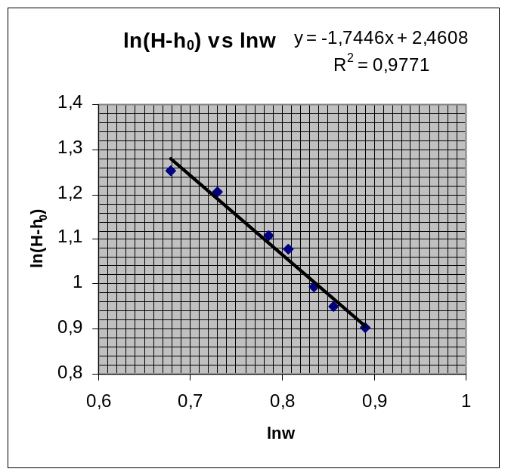
Figure 3.
Thus the focal length depends on w as
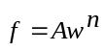,
and
n ~ -1.7.

The plot of H-h₀ vs. 1/w² is also acceptable as a correct plot.

Part 2b

ω Range(rad/s) | Orientation | Variation of the size | Image
ω=0 | ER |  | V
0<ω<8.2*  0<ω<6.3** | ER | D | V
8.2<ω<14.6*  6.3<ω<14.0** | INV | I | R
14.6<ω<ω_{max}*  14.0<ω<ω_{max}** | ER | NC | V

* for H=110 mm
** for H=240 mm

ω values depend on the initial values of H, h₀, etc.

Note that measurements only at one H value are required from the students.

Part 3

Measurement of wavelength

Both the grating and the screen are in air. Normal incidence.

Screen to grating distance : L
Distance between the diffraction spots seen on the screen : x
Order of diffraction : m

- L= 225 mm, x_{av}=77 mm for m=±1 d=1/500 mm
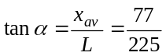
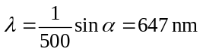
- L= 128 mm, x_{av}=44 mm for m=±1, d=1/500 mm
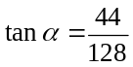
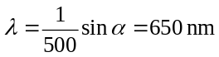
- L= 128 mm, x_{av}=111 mm for m=±2, d=1/500 mm
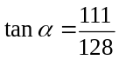
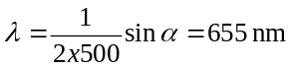

The average value of λ is λ_{av}=651 nm.

Measurement of refractive index

2R=145 mm

Distance between the spots measured on the curved screen = Rα

Rα_{av} = 17 mm for m=±1 α _{av} = 0.234 rad
using 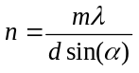, one obtains n=1.40

If the curvature of the screen is neglected:
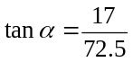
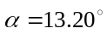
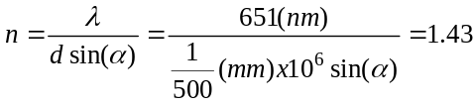

Grading Scheme for Experimental Competition

Part 1 7.5 pts

- Derivation of Equation 1 1.0 pts
- Calculation of ω using period measurements 1.0 pts

At low speeds 10T is OK
At high speeds 20T is expected -0.2 pts
Missing units -0.2 pts

- Calculation of tan2θ, tanθ at each ω 1.0 pts
Calculation of tan2θ 0.5 pts
Calculation of tanθ 0.5 pts

- Plot of tanθ vs ω² 1.5 pts
Axes with labels and units 0.4 pts
Drawing best fit line 0.5 pts
At least 6 different data in a wide range of ω 0.6 pts

No. of measurements 5: -0.2 pts
No of measurements 4: -0.4 pts
No of measurements 3 or less: -0.6 pts

- Calculations 2.0 pts
calculation of slope with unit 1.0 pts
calculation of g 1.0 pts

FULL credit for
9.3<g<10.3 m/s² (±5% error)
For g values credits to be subtracted from the total credit of 7.5:
10.3<g<10.5m/s², 9.1<g<9.3m/s² -0.5 pts
8.8<g<9.1 m/s², 10.3<g<10.8 m/s² -1.0 pts
outside the above ranges -1.5 pts

- Error Calculation 1.0 pts

Part 2a 5.5 pts

- Measurements of H vs ω 0.6 pts
Calculation of ω using period measurements 0.4 pts

At low speeds 10T is OK
At high speeds 20T is expected -0.2 pts
H-ω table 0.2 pts

- Plot of F vs ω 2.4 pts
Calculation of F=H-h₀ 0.5 pts
Plot with axis labels 0.8 pts
Drawing best fit line 0.5 pts
At least 6 different data in a wide range of ω 0.6 pts

No. of measurements 5: -0.2 pts
No of measurements 4: -0.4 pts
No of measurements 3 or less: -0.6 pts

- Calculations 2.5 pts
Calculation of slope with unit 1.0 pts
Dependence Fα 1/ω² 1.5 pts

Part 2b 3.5 pts

- Every correct item in the table 0.25 pts

Part 3 3.5 pts
(At least 3 measurements at different orders are required)

- Wavelength measurement 1.2 pts
Distance measurements and calculation of angle 0.6 pts
Calculation of λ 0.6 pts

Credits to be subtracted from the total credit of 1.2:
If λ is outside the range 600-700 nm -0.4 pts
If less then 3 measurements -0.4 pts

- Measurement of n 2.3 pts
Distance measurements and calculation of angle 0.6 pts
Realizing λ/n 0.8 pts
Calculation of n 0.9 pts

credits to be subtracted from the total credit of 2.3:
If n is outside range 1.3-1.6 -0.4 pts
If less then 3 measurements -0.4 pts

